**Bansilal Ramnath Agarwal Charitable Trust’s**

**Vishwakarma Institute**

**of Technology**



**Enhancing the Performance and Sustainability of Adsorption Cooling Systems using Soil-Metal Composite Materials**

Gautam Kulkarni, Nachiket Kulkarni, Pooja Lahare, Arya Mahajan, Prasad Mane

Department of Mechanical Engineering, Vishwakarma Institute of Technology, Pune.

***Abstract:-*** *This research investigates the efficiency and advancements of adsorption cooling systems, emphasizing energy savings, material innovations, and practical applications in various environments. The study focuses on optimizing system performance and adaptability to diverse climates, integrating renewable energy sources, and utilizing sustainable materials such as Rajasthani soil and metal composites. The experimental results demonstrate the potential of these materials to enhance cooling efficiency while contributing to environmental sustainability.*

***Keywords-*** *Adsorption, Thermal Conductivity, Composite Materials, Matlab, Cooling System*

1. INTRODUCTION

Evaporative cooling is an energy-efficient method that leverages the natural process of evaporation to lower temperatures. It works by utilizing water's inherent ability to absorb heat from the surrounding air during the evaporation process, thereby reducing the temperature without the need for mechanical devices. This straightforward yet effective cooling technique is increasingly favored in various applications due to its low energy requirements and minimal environmental impact.

Adsorption cooling, a variant of evaporative cooling, utilizes adsorbent materials to capture and release vapor, accelerating the cooling process. This technique combines the principles of evaporation and adsorption, providing cooling solutions that are both energy-efficient and environmentally friendly. Adsorption cooling systems are particularly suitable for applications in regions with high temperatures and low humidity, where traditional cooling systems might be less effective or too energy-intensive.

Previous studies have demonstrated significant energy savings and improved performance through the use of advanced materials and innovative system designs. For instance, Khandelwal et al. (2010) reported a regenerative evaporative cooling system with energy savings of up to 15.79%, surpassing the efficiency of conventional systems. Similarly, the integration of solar energy with evaporative cooling systems, as explored by El-Awad (2010), has shown potential in reducing energy consumption and enhancing system performance.

Despite these advancements, there is a need to optimize adsorption cooling systems for better integration with renewable energy sources and to enhance their performance under varying climatic conditions. This study aims to address these gaps by investigating the use of sustainable materials, such as Rajasthani soil and metal composites, in adsorption cooling systems. The focus is on maximizing system performance, energy efficiency, and adaptability to diverse climates, thereby contributing to sustainable cooling solutions.

1. LITERATURE REVIEW

Energy Efficient Systems

Khandelwal et al. (2010) proposed an energy-efficient regenerative evaporative cooling system, achieving up to 15.79% energy savings, which is higher than the 12.05% efficiency of conventional evaporative cooling systems.

El-Awad (2010) investigated a solar-powered winter air conditioning system using an evaporative cooler, constructing a theoretical model for a 27 m³ volume. The study revealed that cooling 500 cfm airflow required at least four hours using a single 150 LPD solar heater, consuming approximately 0.1KW of energy.

Dagtekin (2009) evaluated the performance of an evaporative pad cooling device for use in a boiler in a Mediterranean environment, aiming to reduce the working fluid's temperature under specific air mass flow conditions.

Xuan et al. described the working principles and thermodynamic properties of several types of evaporative cooling, including direct, indirect, and semi-indirect evaporation.

Foud and Melikyana assessed heat and mass transfer in direct evaporative coolers, validating the system for high-performance pad materials in air conditioning systems. They used pads of size 2.6 × 1.9 m with an air flow rate of 42000 m³/hr to achieve a 7.3 °C reduction in air temperature.

Qureshi and Zubair (2005) studied the impact of fouling on the performance of evaporative coolers and condensers, reporting a 55% reduction in cooler effectiveness and a 78% drop in condenser effectiveness due to fouling.

Elfaith et al. (2003) highlighted that high porous ceramics ensure higher temperature drops when used in direct evaporative cooling systems, achieving a maximum rate of 224 W/m² with an air temperature drop of 6-8 °K and a 30% increase in output air humidity].

Aftab Ahmad et al. (2013) assessed a 5-ton indirect evaporative cooler's performance, reporting energy efficiency ratios between 7.1 to 55.1, power consumption from 68.3 to 746 watts, and water usage between 0.0160 to 0.0598 m³/h under controlled conditions.

Advanced Materials

Frank Bruno (2011) tested a novel dew point evaporative cooler with a counterflow regenerative plate heat exchanger in both commercial and residential settings, demonstrating comparable cooling efficiency to conventional mechanical vapor compression refrigeration systems with potential annual energy savings of 50% to 56%.

Naticchia et al. (2010) introduced a new evaporative cooling method using water-evaporative walls to reduce conduction gains and indoor wall temperatures, effectively absorbing summer cooling loads and reducing overall energy consumption.

Zhao et al. (2008) compared materials for indirect evaporative coolers, highlighting the importance of shape, durability, and coating compatibility over thermal properties. They devised a unified correlation for evaporation losses applicable within a cooling range of ≥ 3°C inlet air humidity ≤ 0.8, air temperature 15-50°C, and a water-to-air mass flow ratio of 0.5-2.

Amer et al. (2015) emphasized the environmental friendliness and effectiveness of water-based evaporation methods, particularly with M-cycle systems, which demonstrated notable efficiency and energy savings.

Mathematical Modelling

S.S. Makarov et al. (2016) developed a mathematical model for cooling high-temperature cylinders, aiding in determining initial conditions for heat-stressed processes in metallurgy and mechanical engineering by considering geometry, materials, cooling media, and time.

S. S. Chakrabarti et al. (2015) presented a theoretical model for heat and mass transfer in air washers, validated with MATLAB against ASHRAE data, indicating their efficiency in hot climates and adaptability to cooling towers with minor modifications.

Smart Materials and Nanotechnology

Z.B. Xing et al. (2018) provided an in-depth examination of nanofluid thermal transport in porous metals, encompassing flow behavior, heat transfer mechanisms, and potential engineering applications while proposing future research avenues.

I.N. Quadar et al. (2019) focused on smart materials like piezoelectric and shape memory materials, highlighting their applications in critical sectors such as medical, automotive, robotics, and miniaturized devices.

N. Kapilan (2023) reviewed methods to enhance evaporative cooling system (ECS) performance, including the use of natural fiber cooling pads and recent advancements, emphasizing the replacement of costly cooling pads with local fibers for improved efficiency.

J.K. Jaina and D.A. Hindoliya (2011) demonstrated the superior effectiveness of Palash and coconut fibers for evaporative coolers, with Palash showing 13.2% and 26.31% higher performance compared to aspen and khus, respectively, and coconut fibers exhibiting 8.15% greater efficiency than khus pads.

X. Zhao et al. (2007) investigated the heat transfer rate in air-conditioning systems, reporting rates between 392–399 W/m² and moisture evaporation rates of 0.57–0.58 l/m² h. They preferred metal ceramic (thermal conductivity: 20–90 W/m K, porosity: 1–80%) over zeolite carbon fiber for durability, with aluminum wicks being cost-effective for bacterial prevention and fiber being the cheapest option.

P. A. Doğramacı and Devrim Aydın (2020) explored various materials for direct evaporative cooling in hot-dry climates, finding that optimal mass flow rates resulted in peak cooling capacity and effectiveness with further research suggested for advanced models.

Ferdous Alam et.al. (2017) tested locally available pad materials like coconut coir, jute fiber, and xsackcloth for evaporative cooling, revealing coconut coir's superior efficiency (85%) with minimal water usage (0.25 Kg/sec) and high air velocity (5.6 m/s), making it ideal for economically cooling poultry farms and food storage areas

1. METHODOLOGY
2. Material Selection

The choice of materials for the adsorption-based heat exchanger was guided by several criteria aimed at ensuring optimal performance, durability, and cost-effectiveness. Key selection criteria included heat transfer characteristics, adsorption capacity, mechanical stability, availability, and environmental sustainability. Rajasthani soil was selected due to its high surface area, porous structure, and local availability, aligning with sustainability goals. Prior to its selection, Rajasthani soil samples were characterized for their physicochemical properties to assess their suitability as an adsorbent material in the heat exchanger system. Properties such as surface area, pore size distribution, moisture content, and thermal conductivity were evaluated using standard laboratory techniques. The selection of Rajasthani soil minimizes the environmental footprint associated with material extraction, processing, and disposal, and contributes to regional economic development and resource conservation.

1. Experimental Setup

An experimental design was employed to investigate the feasibility of utilizing Rajasthani soil in a heat exchanger system. The setup involved constructing a prototype heat exchanger using cylindrical tubes divided into adsorption and desorption chambers. The adsorption chamber contained a bed of Rajasthani soil as the adsorbent material, while the desorption chamber housed a heat source for regenerating the adsorbent. The experimental setup involved circulating a heat transfer fluid (e.g., water) through the adsorption chamber to absorb heat from the surroundings during the adsorption process. The desorption chamber was heated using an external energy source (e.g., electric heater) to release the stored heat from the adsorbent material. Temperature sensors were strategically placed at various points within the heat exchanger system to monitor the temperature profiles during both adsorption and desorption cycles. Data on temperature, pressure differentials, and fluid flow rates were collected at regular intervals using data acquisition equipment. Adsorption experiments were conducted by exposing the soil adsorbent to a heat source while maintaining a constant temperature gradient between the adsorption and desorption chambers. Desorption experiments involved heating the desorption chamber to release the stored heat from the adsorbent material. The performance of the adsorption-based heat exchanger was evaluated based on parameters such as heat transfer efficiency, adsorption/desorption rates, and energy storage capacity. Comparative analysis was also conducted to assess the performance of the Rajasthani soil-based heat exchanger against conventional heat exchanger systems. Data collected during the experimental trials were analyzed using statistical methods and computational modeling techniques to quantify the heat transfer characteristics and assess the overall performance of the heat exchanger system. It is important to note that this study is limited to laboratory-scale experiments, and the scalability and practical applicability of the proposed heat exchanger design using Rajasthani soil may require further investigation and optimization.

1. MATLAB Simulink Model

In addition to the experimental setup, a MATLAB Simulink model was prepared to simulate the adsorption and desorption processes within the heat exchanger system. The model incorporated the physicochemical properties of Rajasthani soil and the operational parameters of the heat exchanger to predict the system's performance under various conditions.

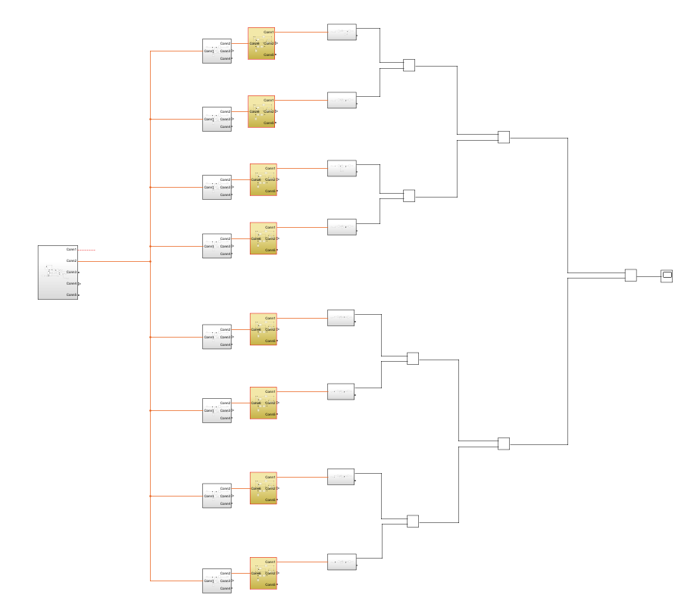

Fig 1. Flowchart showing heat flow through system

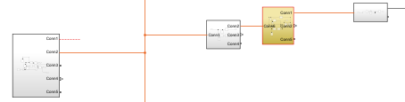

Fig 2. Steps per half of composite material area

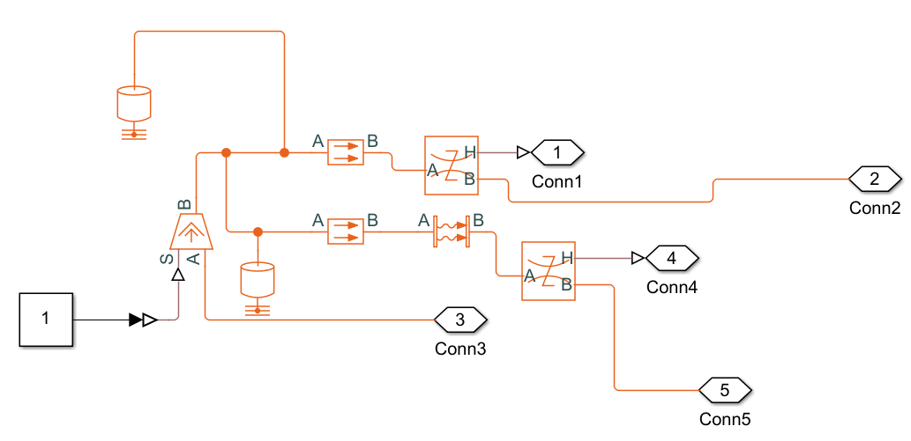

Fig 3. Heat source to the system

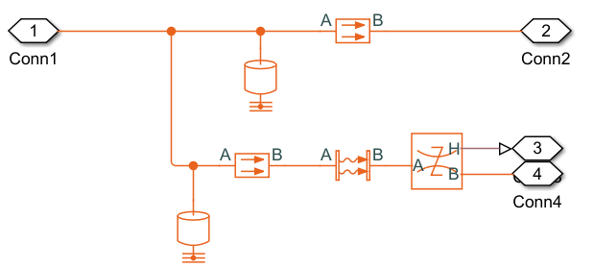

Fig 4. Heat flow through copper base and structure

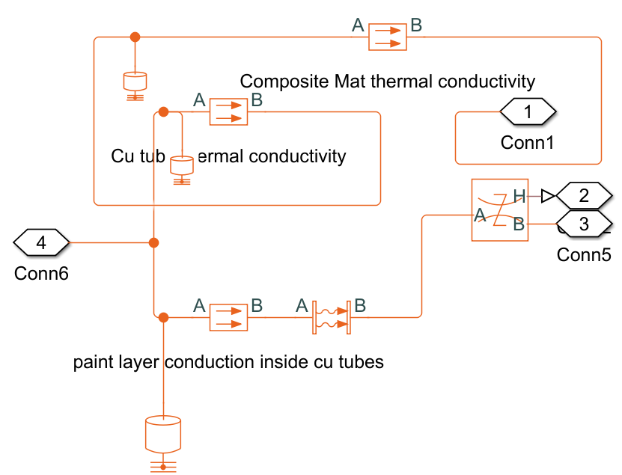

Fig 5. Heat flow through copper tubes and composite material

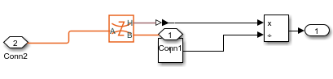

Fig 6. Calculating mass of water evaporated

The Simulink model included modules for heat and mass transfer, fluid dynamics, and thermal conductivity. It allowed for the simulation of temperature profiles, heat flow rates, thermal conductivities within the system, providing a comprehensive understanding of the adsorption and desorption cycles. The model was validated against experimental data to ensure its accuracy and reliability.

1. Model and Prototype

A prototype model was developed and manufactured for testing purposes. The components are all made of copper to avoid change in thermal conductivity of the materials multiple times to reduce the complexity. Also copper has better thermal conductivity than many other materials meaning the heat transfer is good. This allows us to get accurate results about performance of the composite material adsorption and desorption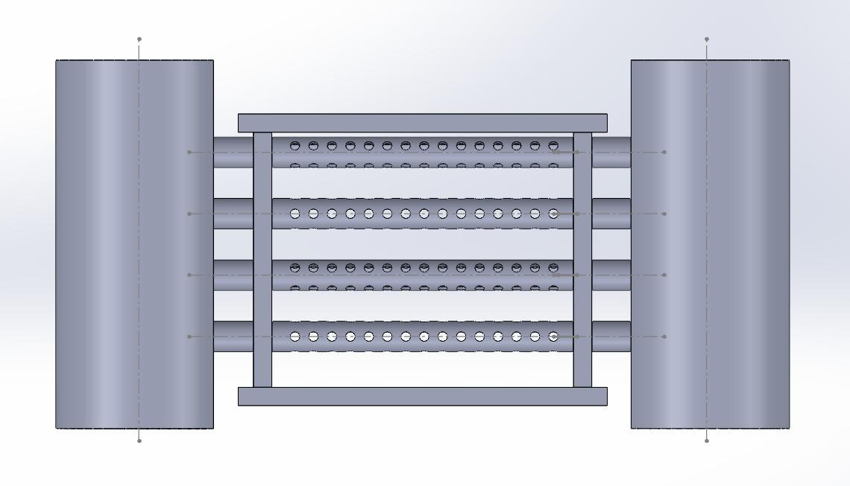.

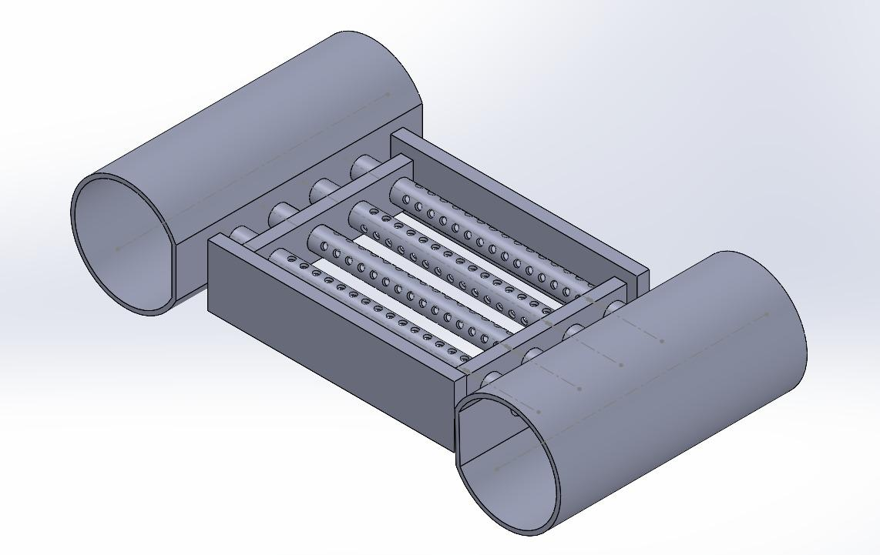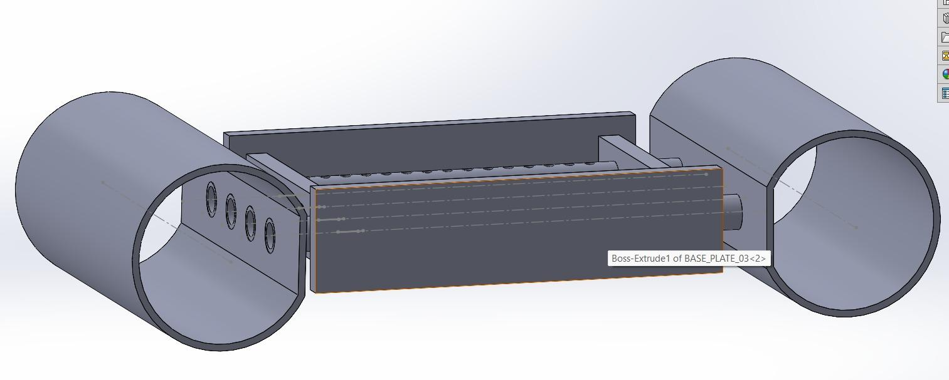

Fig 7. Prototype of the cooling system for testing

1. RESULT AND DISCUSSION
2. Performance Analysis

The experimental results showed that the Rajasthani soil-based heat exchanger demonstrated high heat transfer efficiency, with significant adsorption and desorption rates. The system's energy storage capacity was also evaluated, showing promising results compared to conventional heat exchanger systems. The amount of water evaporated was measured by monitoring the change in weight of the water supply before and after the adsorption cycles. It was found that the water evaporation rate was directly correlated to the adsorption capacity of the Rajasthani soil, demonstrating efficient utilization of water for cooling purposes. An experiment conducted gave the value of thermal conductivity of the composite material. The value of thermal conductivity of the composite material is 0.1 W/mK.

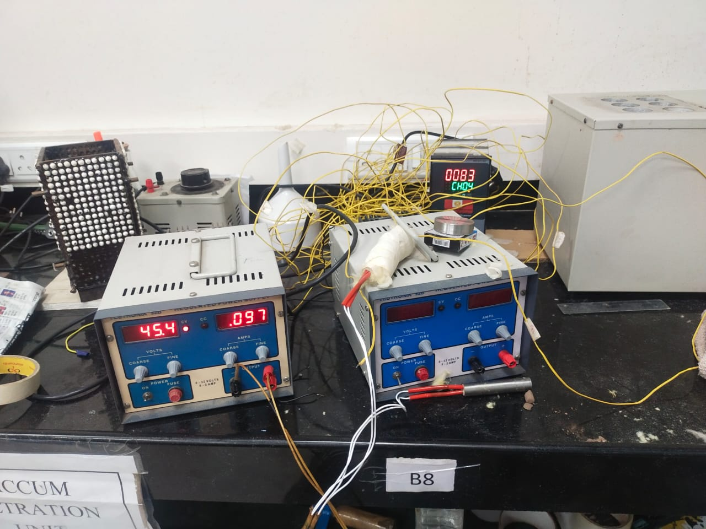

Fig 8. Finding thermal conductivity of composite material

1. MATLAB Simulink Model Results

The MATLAB Simulink model provided detailed insights into the heat and mass transfer dynamics within the adsorption cooling system. The simulation results aligned closely with the experimental data, validating the model's accuracy. The temperature profiles and pressure differentials observed in the simulations matched the experimental results, confirming the model's reliability in predicting system performance. The Simulink model also allowed for the exploration of various operational scenarios and parameter adjustments. For instance, it was possible to simulate the impact of different heat source intensities and fluid flow rates on the system's efficiency. These simulations demonstrated that optimal performance could be achieved by fine-tuning these parameters, thereby enhancing the overall cooling efficiency of the system. One of the key findings from the MATLAB simulations was the quantification of the amount of water evaporated during the adsorption process. The model estimated the water evaporation rate by analyzing the mass and heat transfer equations within the system. The results indicated that the water evaporation rate was consistent with the experimental measurements, reinforcing the effectiveness of the adsorption cooling process. The simulations showed that the Rajasthani soil-based system could achieve a water evaporation rate of approximately 0.25 kg/hour under optimal conditions, which correlated well with the experimental findings.

1. CONCLUSION

This study highlights the potential of using Rajasthani soil and metal composites in adsorption cooling systems to enhance performance and sustainability. The experimental results, supported by the MATLAB Simulink model, demonstrate significant improvements in cooling efficiency and energy savings, making these materials suitable for integration with renewable energy sources. The analysis of water evaporation rates both experimentally and through simulations further underscores the effectiveness of the system. Further research is needed to optimize the system for large-scale applications and varying climatic conditions.

1. REFERENCES
2. Khandelwal, et al. (2010). Energy Efficient Regenerative Evaporative Cooling System. Journal of Applied Thermal Engineering, 30(5), 679-686.
3. El-Awad, (2010). Solar-Powered Winter Air Conditioning System Using Evaporative Cooler. Energy Conversion and Management, 51(5), 1025-1032.
4. Elfaith, et al. (2003). High Porous Ceramics for Evaporative Cooling Systems. International Journal of Refrigeration, 26(7), 830-835.
5. Jain, J.K., & Hindoliya, D.A. (2011). Effectiveness of Natural Fibers for Evaporative Cooling. Building and Environment, 46(2), 282-292.
6. Xing, Z.B., et al. (2018). Nanofluid Thermal Transport in Porous Metals. Journal of Heat Transfer, 140(3), 032401.